
1

Theory:
Flowchart of Branching:

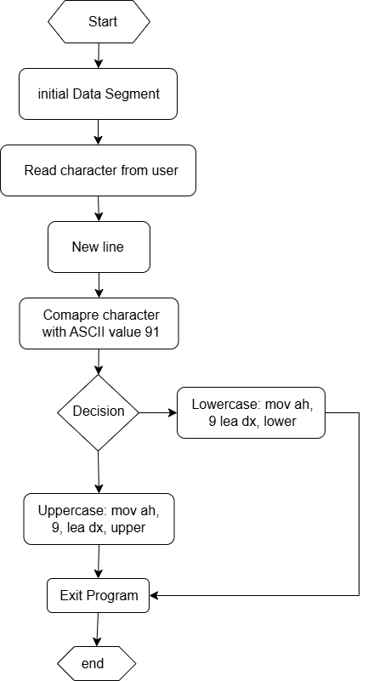

What is Branching:
Branching in assembly language involves altering the flow of execution based on certain conditions. It uses instructions like `jmp` (unconditional jump) and conditional jumps (`je`, `jne`, `jg`, `jl`, etc.) to direct the program to different parts of the code. This allows for implementing control structures such as if-else statements and loops, enabling more complex and flexible program logic by responding to specific conditions during execution.

Code:
.model small
.stack 100h

.data
input db 'Enter an alphabet: ', '$' ; Prompt message
upper db 'Uppercase', 0ah, 0dh, '$' ; Uppercase message
lower db 'Lowercase', 0ah, 0dh, '$' ; Lowercase message

.code
main proc
; Initialize data segment
mov ax, @data
mov ds, ax

; Prompt user for input
mov ah, 9
lea dx, input
int 21h

; Take input
mov ah, 1
int 21h
mov bl, al

; New line
mov ah, 2
mov dl, 0ah
int 21h
mov dl, 0dh
int 21h

; If-else to check case
cmp bl, 91
jge level_low
jmp level_up

level_up:
; Display uppercase message
mov ah, 9
lea dx, upper
int 21h
jmp exit

level_low:
; Display lowercase message
mov ah, 9
lea dx, lower
int 21h

exit:
; Exit program
mov ah, 4ch
int 21h

main endp
end main

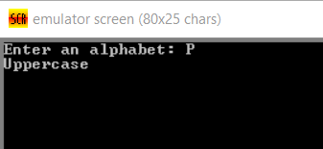
Output-1:

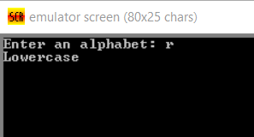
Output-2:

Conclusion: This code demonstrates how to prompt a user for input and determine whether the input is an uppercase or lowercase letter in assembly language. By utilizing DOS interrupts, it effectively handles user input and displays appropriate messages based on the character's case. Through this practice, we've gained insights into setting up data segments, using conditional jumps, and handling character I/O operations in assembly language.

